Instructions: You have 20 minutes to complete this quiz. Note that this is a closed-book, no-device, and closed-notes quiz. You should not communicate with any other person while taking this quiz.

I certify that all the answers on this exam are the result of only my own efforts and that I will not:

- Use the work of others in completing this quiz.
- Provide help to others in their completion of this quiz.
- Employ any electronic devices while completing this quiz.
- Share any information about this quiz with others.

Email: _______________________________

Name: _______________________________

Signature: _______________________________
- Convolution Operation (2 pt). What is the first value in the output feature map here? That is, demonstrate the first calculation of the convolution operation, applying the filter to the first position of the input tensor/matrix.
Input Tensor:
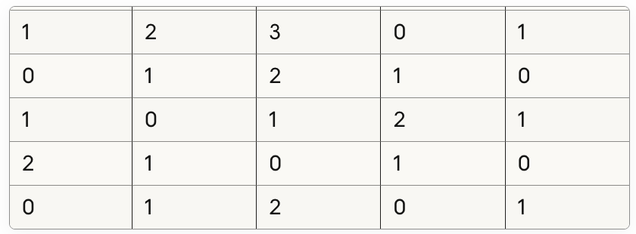
Filter:
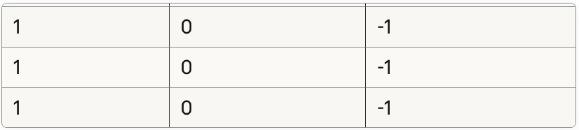

- Pooling (1 pt). Show (draw for me) what a max pooling layer does to an input tensor?

- Filter Count / Feature Map Size (2 pts). How does the number of filters typically change as one goes deeper in a CNN, and how do feature map sizes change? Why does this happen?

